MAP1_14 quick reference

Ray Meddis, University of Essex, Colchester, UK CO7 9SW.

Email: rmeddis@essex.ac.uk.
Update 27 May 2011

MAP1_14 is a simple and fast version of the MAP model. It is a single function that includes all stages of the auditory periphery including efferent effects (acoustic reflex) and MOC attenuation. MAP1_14 has full efferent functionality; both acoustic reflex and MOC efferent functions are automatically enables

Folder structure
The model is contained in a function called MAP1_14. This function can be found in MAPmodelling\MAP1_14*\MAP. The ‘*’ allows for version changes within the MAP1_14 series.
Other folders within MAP1_14* include parameterStore, utilities, wavFileStore and testPrograms. Another folder is called ‘multithreshold 1.46’. This contains psychometric testing software which can be harnessed to the MAP model.
The modules folder to be found in earlier versions of MAP no longer exists as the program is no longer modular in the interests of speed

test_MAP1_14.m
To get started, a simple test program is available in the testPrograms folder.
To use MAP1_14, open the MAPmodelling\MAP1_14*\testPrograms folder and run test_MAP1_14.
This test program offers various options. To run the model using only probabilistic estimates of AN spiking rates, set
MAPrequests.AN_spikesOrProbability= 'probability';
This runs a full efferent model but the efferent control is based on the AN firing rates only. This option is very fast (almost 2 x real time for a 21-BF model). This should do nicely for speech recognition. To check this out select
signalType= 'file';
The following figure should appear for a 65 dB signal level:
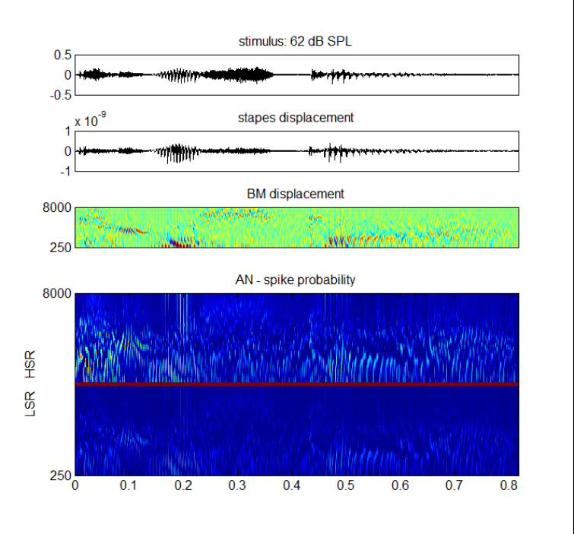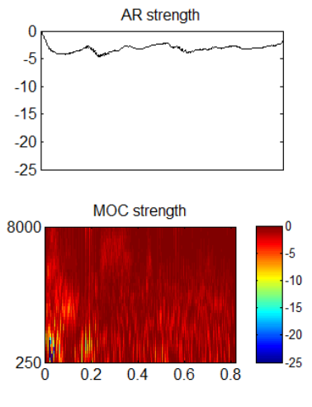
Fig. 1 Output of the ShowMAP function when the test_MAP1_14 demonstration program is used. The output will vary depending on the options chosen in test_MAP1_14.
The bottom panel on the left shows the probability of a spike in AN fibers at BFs ranging from BF=250 to 8000 Hz. The top of this panel shows HSR fibers and the bottom of this panel shows LSR fibers. The figure to the right shows the strength of the efferent attenuations for both AR and MOC .

MAP1_14.m
The main function is MAP1_14 and is located in the MAP folder. The function call is
MAP1_14 (inputSignal, sampleRate, BFlist, MAPparamsName, AN_spikesOrProbability, paramChanges)
inputSignal is a mono row vector in Pascals
sampleRate is sample Rate (Hz)
BFlist is a list of BFs but can be ‘-1’. In the latter case the parameter file specifies the BFlist
MAPparamsName e.g. ‘Normal’, used to make name of parameter file (e.g. MAPparamsNormal).
AN_spikesOrProbability
=’probability’ for AN model based on probabilities (best for Speech recognition).
=’spikes’ for full model as used in psychophysical tests.
paramChanges is a cell array of strings containing commands to change model parameters after loading them from the MAPparams* file. This argument is optional but may be used by calling programs to explore the effect of parameter changes. For example,
paramChanges{1}= 'DRNLParams.a=0;';
This example disables the nonlinear path in the DRNL model of BM response (in effect, disabling OHC function). These parameter changes overrule whatever is to be found in the MAPparams* file.

Outputs
The function returns no arguments. All results are stored in global variables. The most commonly required will be ANprobRateOutput which is a BF x duration matrix of estimated spiking rates using the sample rate specified in the function call.
If the full spiking model is chosen, ANoutput, CNoutput ,and ICoutput are logical matrices containing the rasters of spikes at each level. Each row in the matrix represents the firing of a single AN fiber or a single CN or IC neuron.
All values are international units (m, s, Pa, V, A)
The following global statement gives the calling program access to all important results
global dt ANdt savedBFlist saveAN_spikesOrProbability saveMAPparamsName...
savedInputSignal OMEextEarPressure TMoutput OMEoutput ARattenuation ...
DRNLoutput IHC_cilia_output IHCrestingCiliaCond IHCrestingV...
IHCoutput ANprobRateOutput ANoutput savePavailable tauCas ...
CNoutput ICoutput ICmembraneOutput ICfiberTypeRates MOCattenuation

Output examples
The variable saveAN_spikesOrProbability indicates whether ‘spikes’ or ‘probability’ computations were requested.
If MAP1_14 is run in probability mode, the AN spike rate matrix (channels x time) can be found in ANprobRateOutput. If only one type of fiber is used, each channel refers to a single best frequency (BF). The list of best frequencies can be found in savedBFlist. If two fiber types are used (e.g. HSR and LSR) the top half of the matrix will be the output from one type of fiber and the bottom half from the other. The sampling interval is dt.
If MAP1_14 is run in spikes mode, the AN spiking output will be found in the matrix ANoutput. This is a logical matrix (0/1). The sampling interval is ANdt. The sampling interval is longer for these computations. Each row of this matrix is an individual fiber. All fibers with the same BF and fiber type are in adjacent rows. Fiber types are segregated with HSR fibers at the top if more than one type has been requested.
In both cases the amount of efferent activity can be monitored using the variables ARattenuation (single row vector) and MOCattenuation (matrix BFs x time).

Program structure
The function has two stages; the first simply allocates memory and does all computations that need be done only once. The second stage computes the model segment by segment as quickly as possible.

showMAP.m
This function plots the output from the most recent MAP1_14 call. It assumes that all results are already present in global storage. It generates the figures shown above.
showMAP.m is located in the MAP folder. It has no arguments and returns no results. Two figures are generated based on the results of the previous run which will be stored in global variables.
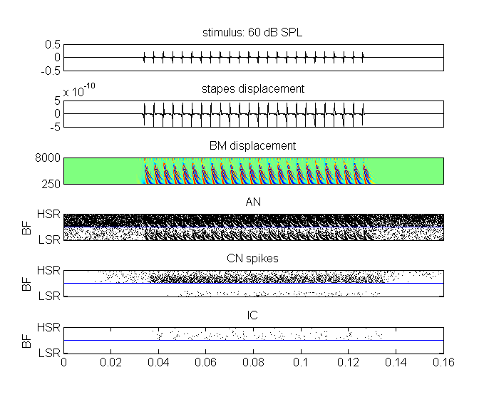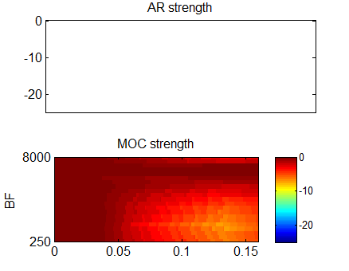
Fig 2. showMAP output after a test_MAP1_14 run. A spiking model has been chosen and the stimulus is a pulse train consisting of all harmonics of F0=250 Hz up to 8 kHz (50 dB SPL per harmonic). Note that the spike patterns of AN, CN and IC units are divided into two halves because LSR (top half of each panel) and LSR (bottom half) are used. The right-hand panel shows the pattern of AR and MOC attenuation. There is no AR but the MOC attenuation builds up to moderate levels as the signal continues.
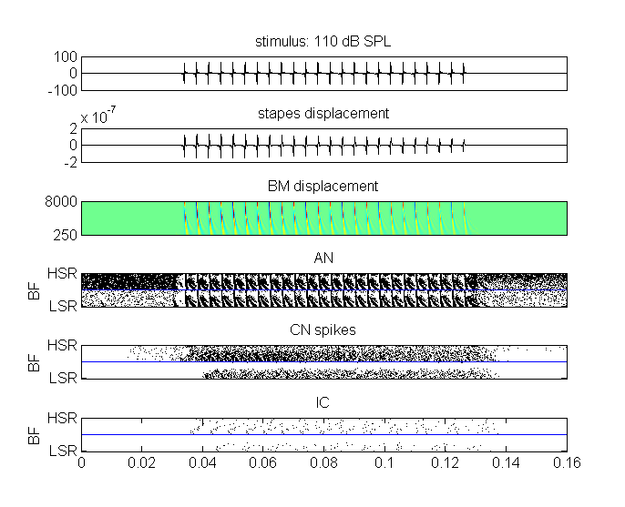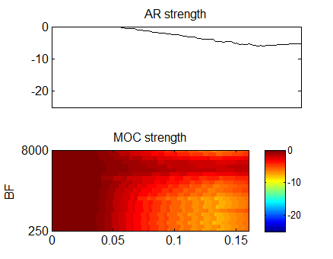
Fig 3. showMAP output after a test_MAP1_14 run (same as Fig. 2 but the individual harmonics are more intense at 100 dB SPL each). The right-hand panel shows the pattern of AR and MOC attenuation. On this occasion (compare Fig. 3) the AR is now active.

Warning
The current version makes no checks on model parameters in terms of how sensible they are. However, all parameters are in international units and should be physiologically plausible.
